**AI ASSSITED CODING**

**LAB-6:**

**HTNO:2503A52L11**

**Lab 6:** AI-Based Code Completion: Working with suggestions for classes, loops,  
conditionals  
Lab Assignment 1: Intelligent Code Completion for Object-Oriented Programming  
Objective: To explore AI-powered code assistants for writing Python classes,  
constructors, and methods through intelligent suggestions.  
Suppose that you are hired as an intern at a tech company that develops inventory  
management systems. Your manager asks you to create a Product class and a  
Warehouse class with some basic methods. You have decided to use AI-powered code  
suggestions to help speed up development and reduce syntax errors.  
Tasks to be completed are as below  
1. Setup AI Coding Tool:  
• Install and configure GitHub Copilot or Kite with VS Code or JetBrains IDE.  
• Enable real-time code suggestions.  
2. Class Design Using AI Assistance:  
• Begin defining a Product class with attributes: name, price, quantity.  
• Use the AI suggestion feature to automatically complete the __init__() method.  
• Add a method calculate_value() to return price * quantity.  
15.08.2025 EOD

3. Create Another Class:  
• Define a Warehouse class with a list of Product objects.  
• Use code completion to help implement:  
o A method to add a product.  
o A method to display the most valuable product.  
4. Reflection:  
• Identify how much of the code was completed by AI and what manual edits  
were needed.  
• Comment on the relevance and accuracy of AI suggestions.  
Requirements:  
• VS Code with Github Copilot or Cursor API and/or Google Colab with  
Gemini  
Deliverables:  
• Python script with both classes and comments on AI-generated suggestions.  
• Short report (1 page) summarizing your experience with AI code completion.

**CODE:**

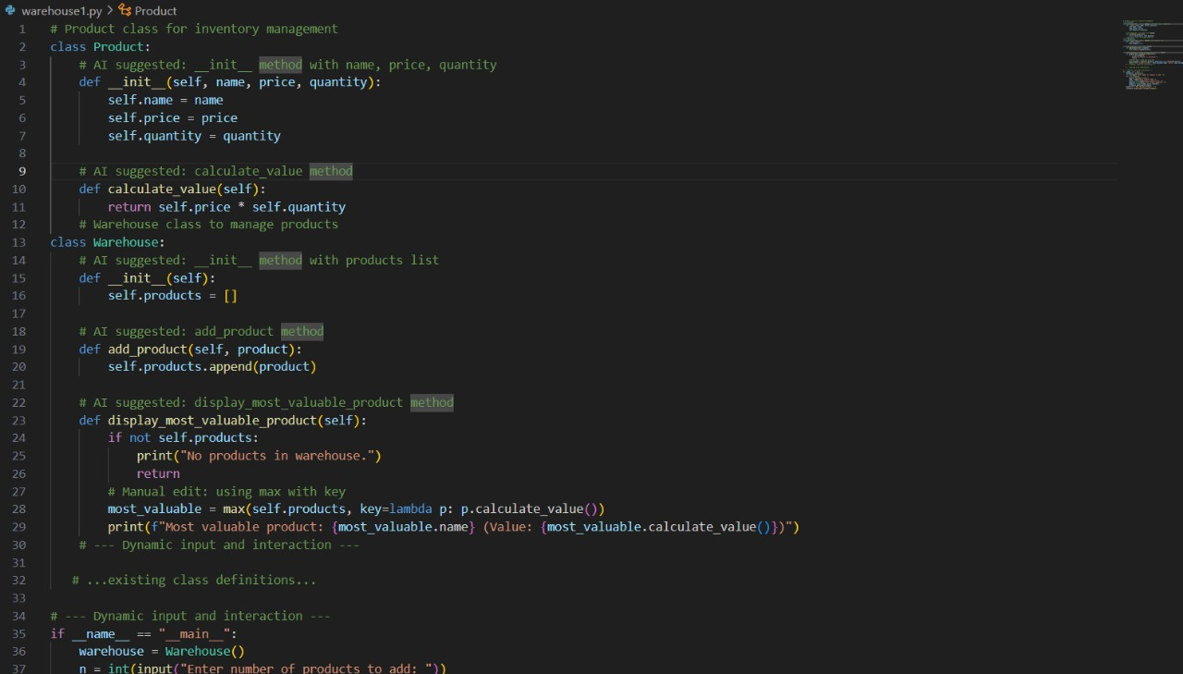

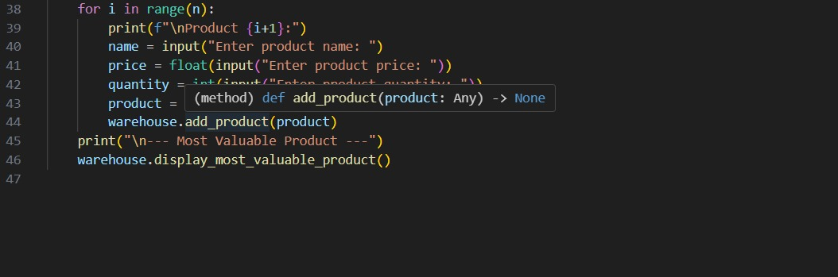

**OUTPUT:**

